# Day 2 - Point DNS and Join the Domain

1. **Point `dc02`'s DNS at `dc01` before doing anything else.**
- new server can't find an existing domain if it's still using Azure's default DNS — it has no way to resolve `ad.karabonode.co.za` or find the SRV records from Week 2 Day 1

Private address for the dc01-karabonode:
172.16.0.4

Okay.. seems like I made an issue when selecting the vnet for the 2nd vm, unfortunalety it looks like ill have to delete and recreate it under the same vm as dc01, reason being the dc replication requires both network to be on the same vnet
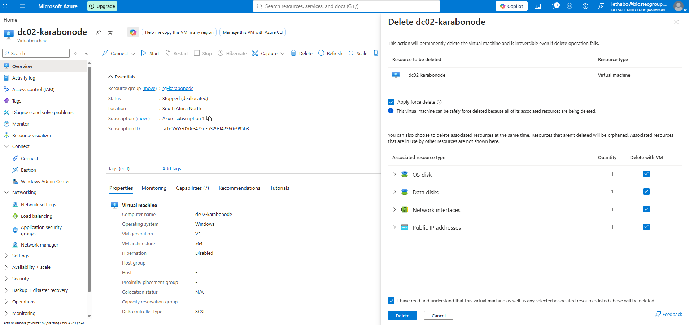
# confirm the adapter alias, usually "Ethernet"
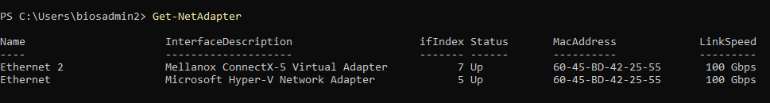
This is the real action. It changes which DNS server dc02 asks when it needs to resolve names, replacing Azure's default DNS with dc01's private IP

**Confirm resolution works** before attempting promotion:
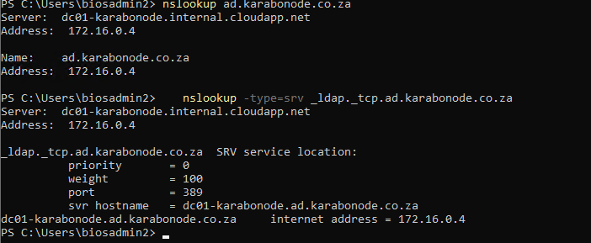

3. **Install the AD DS role** (same as Week 1 Day 3 on `dc01`):
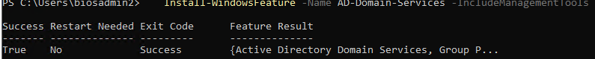

Dry-run the promotion (the safety net)

`Test-ADDSDomainControllerInstallation` runs the full prerequisite validation with the real parameters but **changes nothing** — no join, no reboot, no half-promoted state:

```powershell
Test-ADDSDomainControllerInstallation `
-DomainName "ad.karabonode.co.za" `
-Credential (Get-Credential "KARABONODE\Administrator") `
-DatabasePath "F:\NTDS" `
-LogPath "F:\NTDS" `
-SysvolPath "F:\SYSVOL" `
-InstallDNS `
-SafeModeAdministratorPassword (ConvertTo-SecureString "Your-Strong-DSRM-Password!" -AsPlainText -Force)

